

]
[

]

[

University of Engineering and Technology
,

Taxila

Data Structure and Algorithm

Lab
# 01

Nam
e:

Subhana Shoukat

Roll
No
:
23
-
CP
-
65

Submit T
o:

Sir Shehriyar

Lab Title: Python Basics and Foundations
Lab Objectives:
● Build a strong foundation in implementing and manipulating 1-D, 2-D, and 3-D arrays using Python's object-oriented programming approach.
● Learn to design solutions for real-world problems by leveraging array operations and object-oriented principles.
● Utilize arrays to develop real-life applications such as to-do list managers, library systems, and 3D maze solvers.
● Demonstrate using arrays in designing features for complex systems such as social media platforms and image processing tools.
Task 1:
To-Do List Enhancement:
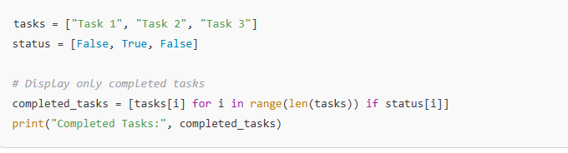
Task2:
Daily Expense Calculator:
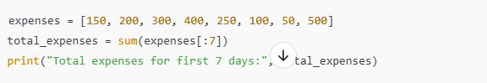
Task3:
Student Grade Summary:
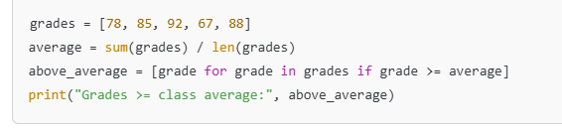
Task4:
Find the Maximum Element
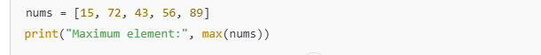
Task5:
Simple Library Search
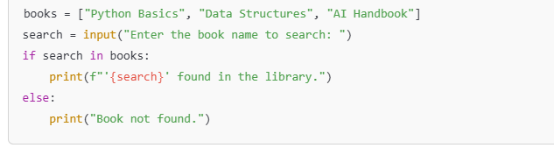
Task6:
Expense Breakdown by Category
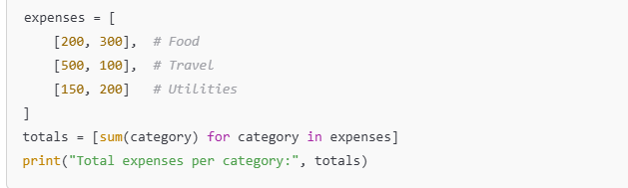
Task7:
Attendance Tracker
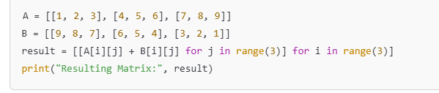
Task 8:
Sort Grades
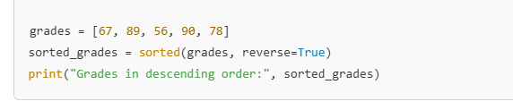
Task 9:
2-D Tic-Tac-Toe Enhancements:


